7.A college employs a large number of security personnel who are assigned duties at various locations across the campus. Each security person follows a duty schedule that includes date, duty start time, duty end time, and assigned location, ensuring that every campus location is covered. If a security person takes leave, it is recorded manually, and at the end of each month, salaries are calculated based on duties performed and leaves taken. Since manual handling of duty allocation, leave management, and salary calculation is time-consuming and complex, the college plans to develop an Online Security Management System to automate these activities. Develop Class Diagram, Use case Diagram and Activity Diagram to represent the workflow of the Online Security Management System.

Aimz
To design the Class Diagram and Use Case Diagram for an Online Security Management System that automates security personnel management, duty scheduling, leave management, salary calculation, and report generation.

Procedure for Class Diagram
- Study the problem statement and identify the system requirements.
- Identify the main classes involved in the system, such as Online Security Management System, Security Officer, Security Personnel, Duty Schedule, Leave, and Salary.
- Define the attributes for each class (e.g., personnelId, name, scheduleId, leaveId, salaryId).
- Define the operations (methods) for each class (e.g., assignDuty(), applyLeave(), calculateSalary(), generateReport()).
- Identify the relationships and multiplicities between the classes.
- Draw the class diagram using UML notation in Umbrello.
- Verify that all classes, attributes, operations, and relationships correctly represent the system.
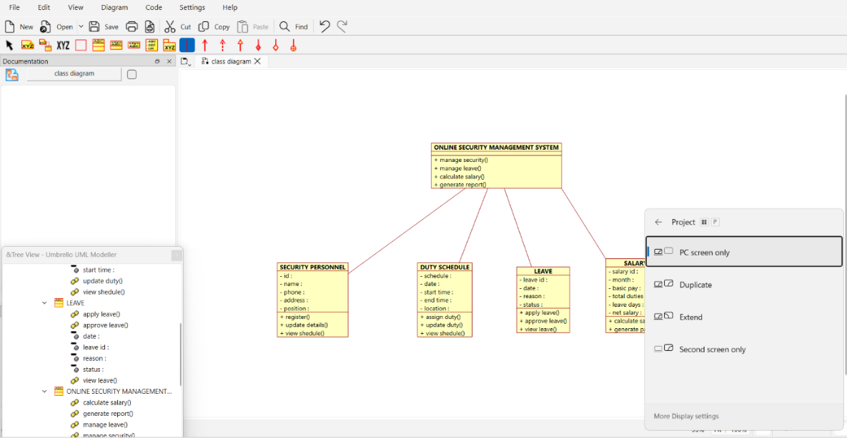

Procedure for Use Case Diagram
- Study the problem statement to understand the system functionalities.
- Identify the actors interacting with the system, such as Security Officer and Security Personnel. 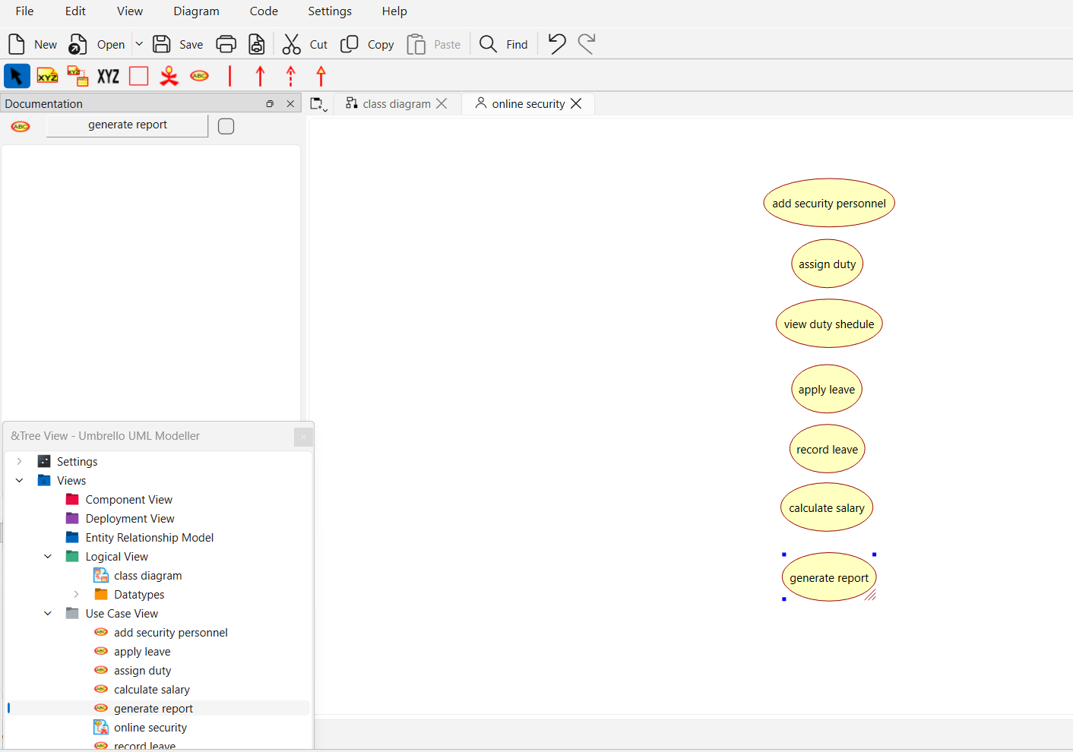
- Identify the use cases performed by each actor.
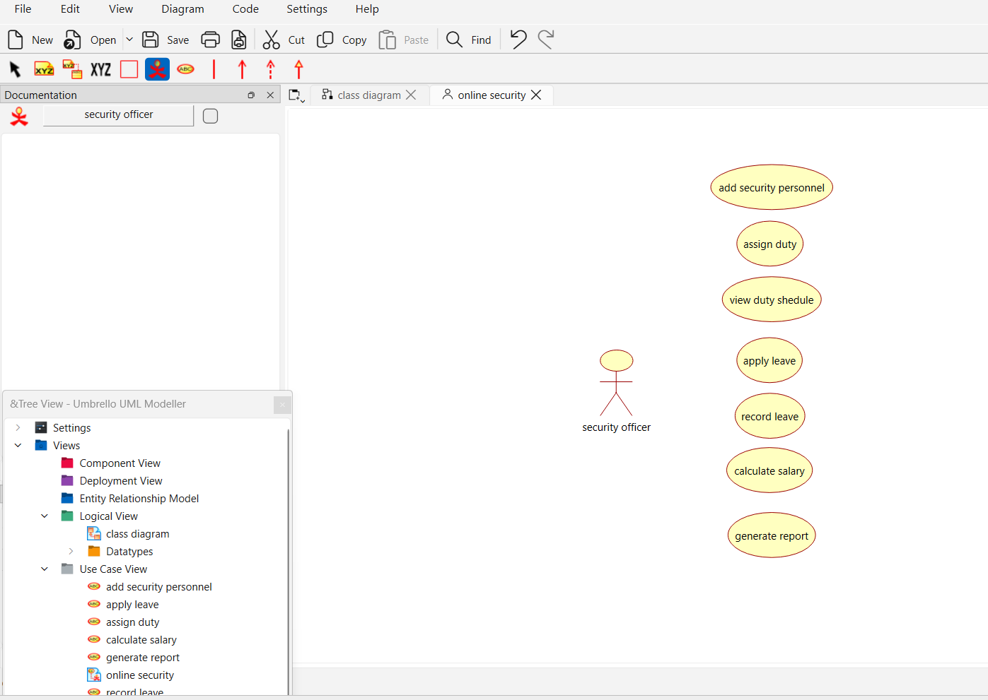
- Draw the system boundary named Online Security Management System.
- Place all the use cases inside the system boundary.
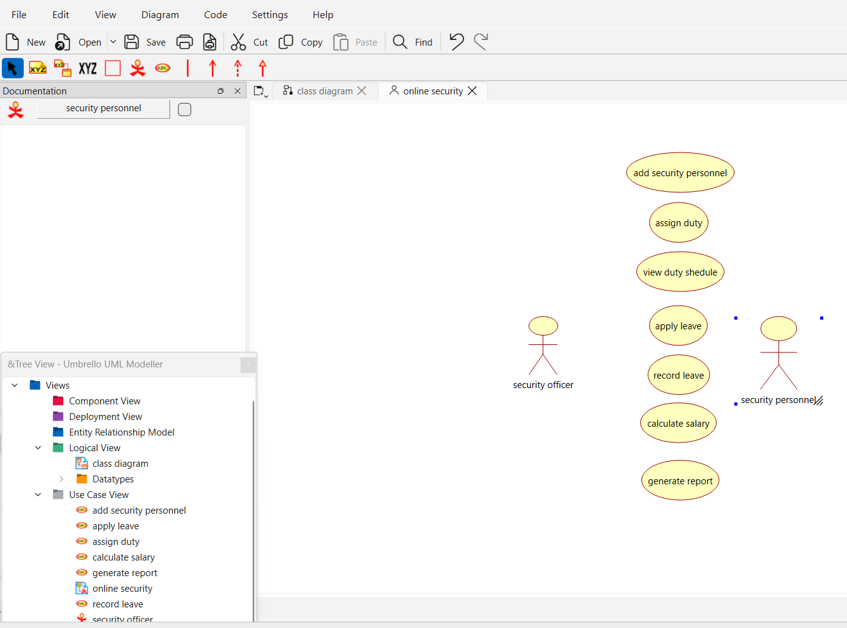
- Connect the actors to their respective use cases using association lines.
- Verify that all user interactions with the system are represented correctly using UML notation.
